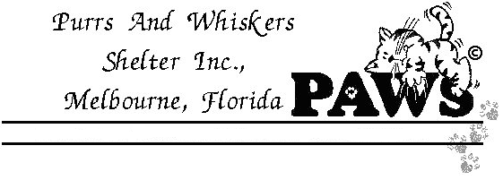
Donation Page
4251 Turtle Mound Road ~ Melbourne, FL 32934 ~ Phone/ Fax: 321-752-5120
*Please print and fill out completely and then return to PAWS
Name_______________________________________________________________ Address_____________________________________________________________
City_____________________________ State______________Zip______________
Home Phone________________________ E-mail_____________________________
I wish to support the "Building Fund" for Purrs And Whiskers Shelter, Inc.
( ) I would like to make a donation. Enclosed is my contribution of $__________
( ) I would like to become a Friend of PAWS at the following level:
( ) $20 Kitten
( ) $35 Sponsor
( ) $50 Patron
( ) $100 Benefactor
( ) $250 Top Cat
( ) Other $______
( ) I would like to donate in memoriam of a special kitty or person in the amount of $_______
I'd like to honor:___________________ or remember____________________
( ) Please bill my: ( ) VISA ( ) Master Card ( ) American Express
Card Number:______________________________ Exp. Date:_______________
Signature:_________________________________________________________
Bequests: You can leave a legacy of kindness and care for our wonderful cats. All sizes of bequests are important sources of support for the shelter. We recommend you consult your attorney to decide which arrangements best suit your individual circumstances.

